Program Data Provider

Git Repository Guidelines

Version Number: 1.3
Version Date: June 22, 2026
Draft

Business Intelligence Program Data Provider (PDP)
Strategic Services Compliance Data Division (SSCD)
Compliance Management Directorate (CMD)
Information Technology Branch (ITB)
Canada Revenue Agency

Services du programme d’intelligence d’affaires (SPIA)
Division des services stratégiques et des données d’observation (SSDO)
Direction de la gestion de l'observation (DGO)
Direction générale de l'informatique (DGI)
Agence du revenu du Canada

Document Version History
Table 1: Document Version History
Version # | Version Date | Author | Revision Notes
1.0 | August 15, 2025 | Jason Ryan | Initial draft.
1.1 | December 12, 2025 | Jason Ryan | Added branching strategy details.  Added repository workflow.
1.2 | June 2, 2026 | Jason Ryan | Renamed document to Program Data Provider Git Repository Guidelines.
1.3 | June 22, 2026 | Jason Ryan | Updated references from local to remote repository.  Updated repository folder structure.
1.4 | August 18, 2026 | Jason Ryan

Table of Contents
1 Document Version History 1
2 Document Overview 3
2.1 Effective Date 4
2.2 Purpose 4
2.3 Audience 4
2.4 References 4
3 Code Deployment Pipeline 4
3.1 Deployment Diagram 5
3.1.1 Heading 3 5
4 Repository Naming Convention 5
4.1 Format and Definition 6
4.2 Examples 6
5 Git Repository Branching Strategy 6
5.1 Repository Diagram 7
5.1.1 Repository: Main Branch 7
5.1.2 Repository: Hotfix Branch 7
5.1.3 Repository: Development Branch 7
5.1.4 Repository: Remote Repository Workspace 7
6 Repository Structure 8
6.1 Folder Structure 9
6.1.1 Heading 3 9
7 Code Repository Workflow 9
7.1 Install git-remote-codecommit 10
7.2 Git Config 10
7.3 Create a remote repository workspace 10
7.3.1 Cloning the repository 10
7.3.2 Change remote repository branch 11
7.3.3 Stage file(s) to include in your next commit 13
7.3.4 Commit changes to remote repository workspace 14
7.3.5 Push changes to CodeCommit repository 14
7.3.6 Deleting the remote repository workspace 15
8 Deployment via Code Pipeline 15
8.1 Development Pipeline 16
8.2 Main Pipeline 16
9 AWS CLI 16
9.1 Commands 17
10 Descriptions 17
10.1 Environment 18
11 Appendix A 19
11.1 Glossary of Terms 19
12 Appendix B 19
12.1 Appendix B Sub-heading 20
13 Document Element Templates 20
13.1 Tables 21
13.2 Figures 21

Document Overview

Effective Date
The AWS CodeCommit Guidelines came into effect on Month DD, YYYY.

Purpose
The purpose of this document is to detail the Git Repository guidelines and usage within PDP for ETL development on the cloud.
The purpose of this Git Repository Guidelines document is to establish standards and best practices for managing source code, scripts, infrastructure automation, and configuration files. These guidelines ensure consistency, collaboration, security, quality, and traceability across the team.
The document defines how repository changes are created, reviewed, tested, approved, and deployed, including standards for branch naming, commit messages, pull requests, and merge strategies. It supports code quality through code reviews, testing requirements, documentation updates, and adherence to established standards.
The guidelines also improve collaboration by providing a consistent workflow, reducing conflicts, supporting onboarding, and making repository history easier to understand. They support change management and auditing by ensuring changes are traceable, accountable, and properly documented.
In addition, the guidelines help protect critical branches and production environments through approval processes, branch protection policies, and controlled change management procedures. Security requirements help prevent the exposure of credentials, enforce dependency management, and promote secure development practices.
Overall, these guidelines provide a consistent framework for managing repository changes, improving quality, reducing risk, and supporting reliable, secure, and auditable operations.

Audience
This guideline is intended for all personnel who contribute to, review, approve, deploy, or maintain assets within DataOps Git repositories, including:

- PDP Developers (a.k.a. Data Engineers) – Responsible for developing and maintaining data pipelines, ETL/ELT processes, and data integration solutions.
- Who is the intended Audience? Should we include “Data Scientists, DataOps Engineers, Platform and Cloud Engineers and others”
- <group 2>
- <group 3>

References
Related documents and information:
- AWS CodeCommit Documentation
- What is AWS CodeCommit? - AWS CodeCommit (User Guide)
- What About Azure DevOps? Any documentation related to that?
- <item 3>

Code Deployment Pipeline
<text for Heading 1>

Deployment Diagram
This diagram shows the flow of code from remote repository workspace to the project code repository and how the Code Pipeline processes managed by CPSS Infrastructure team deploys the code in separated environments to facilitate testing prior to migration to higher states.

Heading 3
<text for Heading 3>

Repository Naming Convention
The following section defines the naming convention for code repositories.

Format and Definition
Format: {environment}-{eapplid}-{owner}-{source-identifier}-repo
Table 2: Definition of Git repositories
Field | Description
- | Static character (hyphen) used as field separator  Type: Alphabetic
{environment} | AWS Environment (see section 10.1)  Type: Alphabetic
{eapplid} | eApplid (eApplid for Program Data Provider is “kg01”)  Type: Alphanumeric  Reference: PACMAN eApplID
{owner} | Source Name (owner for Program Data Provider is “pdp”)  Type: Alphanumeric
{source-identifier} | Identifier specific to source (example, DBID)  Type: Alphanumeric
repo | Static text to represent code repository  Type: Alphabetic

Examples
Table 3: Examples of Git repositories
Field | Description
dev-kg01-pdp-kgtc-repo | Code repository for KGTC (CORTAX)
dev-kg01-pdp-kgtj-repo | Code repository for KGTJ (GHRAPS)
dev-kg01-pdp-kgxx-repo | Code repository for KGXX (name)

Git Repository Branching Strategy
The code repository branching model for Git.

Repository Diagram
Figure 1: Diagram of the code repository branching model

Repository: Main Branch
The purpose of the main branch is to contain production-ready code that has been tested in lower states and is ready for release to higher environments (test, prod).
Migration to higher states is controlled by the Code Pipeline process managed by CPSS Infrastructure.

Repository: Hotfix Branch
The purpose of the hotfix branch is to contain development changes that are required to address emergency/urgent incidents.
The hotfix should be merged back into the main and development branch to ensure the hotfix persists in future releases.

Repository: Development Branch
The purpose of the development branch is to contain pre-test and pre-production code with new features that are in the process of being tested to support release requirements.

Repository: Remote Repository Workspace
The purpose of the remote repository workspace is to contain pre-development code with new features that are in the process of being developed but only undergone unit testing conducted by the developer. The developed features are assumed to not be ready for integration testing until committed to the development branch.
Once the pre-development code has been tested and committed to main branch and the release requirements are complete, the remote repository workspace can be deleted.
The remote repository workspace is a transitory branch for development activities and can be created and deleted as necessary.

Repository Structure
The repository should be organized in a clear and logical structure. Each source repository must minimize deviations from the common structure.

Folder Structure
The folder structure of the repository needs to follow a rigid structure to ensure the repository integrates with the code pipelines managed by the Data Ops Engineer role (CPSS Infrastructure).
In addition to the folders, there are mandatory files used by the pipeline process that need to be in place. These files are not expected to need modification, and if modification is required, detailed analysis is required prior to any changes.
Folders are bolded in the tree displayed below.
{env}-{eapplid}-{owner}-{source-identifier}-repo
├───README.md
├───buildspec.yaml
├───buildspec-script-copy.yaml
├───infra/
│ ├───params/
│ │ ├───pipeline-config-dev.json
│ │ ├───pipeline-config-test.json
│ │ └───pipeline-config-prod.json
│ └───templates/
│ ├───main-cfn.yaml
│ └───nested/
│ └───{service-name}[-{wildcard}]-cfn.yaml
└───scripts/
└───{service-name}/
└───{file-name}.py

Heading 3
<text for Heading 3>

Code Repository Creation
Deployment of committed code.

Create the Azure Repository (manual)

https://dev.azure.com/cra-arc/_git/CMD-SSCD-PDP

Follow repository naming conventions detailed in an earlier section.
Click Create
When your code is pushed to the development branch of the CodeCommit repository, the development pipeline will launch. This is an automated process
kg01-pdp-{source-identifier}-sbic-development

Main Pipeline
When your code is pulled to the main branch of the CodeCommit repository, the main pipeline will launch. This is an automated process
kg01-pdp-{source-identifier}-sbic-main

Code Repository Workflow
<text for Heading 1>

Install git-remote-codecommit
To install git-remote-codecommit, use the following command:
pip install git-remote-codecommit
Reference: Setup steps for HTTPS connections to AWS CodeCommit with git-remote-codecommit - AWS CodeCommit

Git Config
Prior to working with git you should configure your git setting. These settings are reflected in your commits and can be changed at any time. Configuration is only required one time, unless changes are required.
git config --global user.name "Your Name"
git config --global user.email "first.last@cra-arc.gc.ca "
Examples:
git config --global user.name "jxr217"
git config --global user.email "jason.ryan@cra-arc.gc.ca"
To review your git configuration:
git config --list

Create a remote repository workspace
Using VS Code, you will clone the existing source repository to create a remote repository workspace to begin release development. This workspace is available only to the developer and contains in progress development not yet committed back to the development branch of the source repository.

Cloning the repository
To clone the repository, use the following command:
git clone {url} {remote-repo-name}
Example:
git clone codecommit::ca-central-1://dev-kg01-pdp-kgtc-repo jxr217-kgtc-cr-12345
The url of the CodeCommit repository can be found in AWS CodeCommit > Repositories, under HTTPS (GRC).
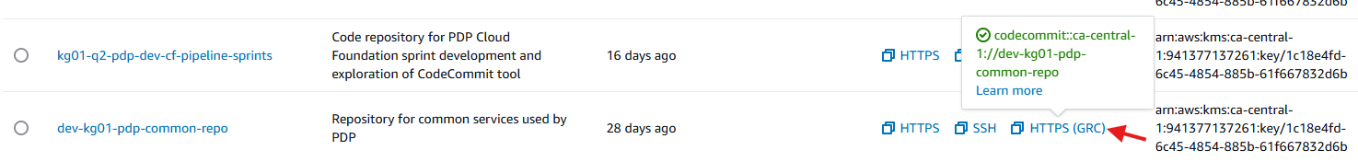
Terminal output of git clone command:
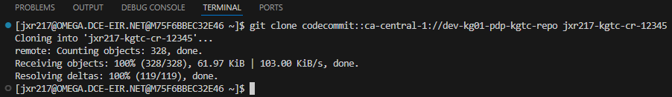
Explorer updated with new repository folder:
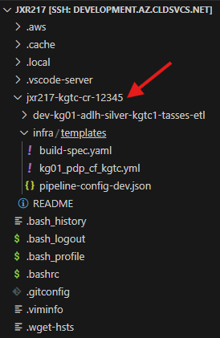

Change remote repository branch
Before beginning development, you will need the select the branch you want to made changes in. Assume you will start with changes in the development branch.
The current branch is displayed in the bottom left corner.
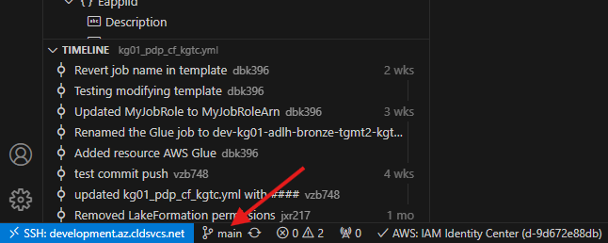
Select ‘main’ and then a dialog will appear in the middle top of the screen. Select the ‘origin/development’ branch.
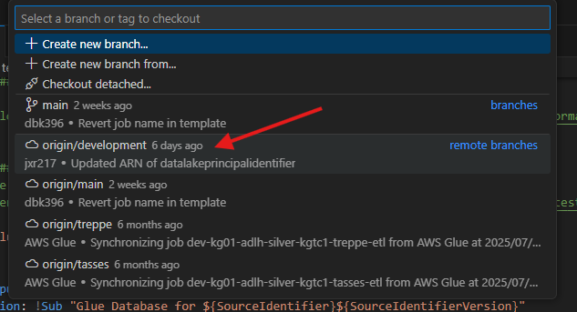
The selected branch will be reflected in the bottom left corner.
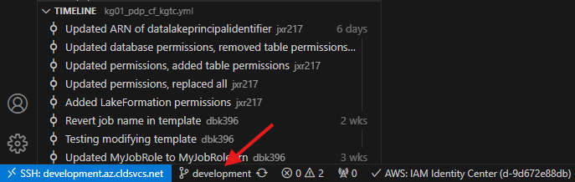
The files in Explorer are the files from the development branch.

Stage file(s) to include in your next commit
To commit changes to remote repository, use the following command:
git add {path}/{filename}
git add {filename}

Examples:
git add infra/templates/kg01_pdp_cf_kgtc.yml
git add kg01_pdp_cf_kgtc.yml
To review what has been staged, use the following command:
git status
Example pre-staging:
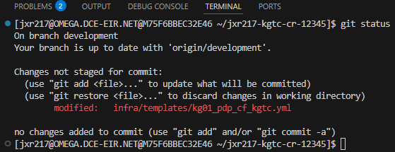
Example post-staging:
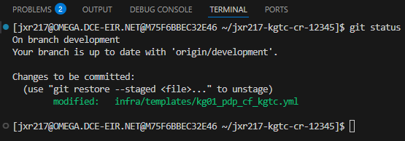

Commit changes to remote repository workspace
To commit changes to remote repository, use the following command:
git commit -m “message”
Example:
git commit -m "Add Glue Database to template"
When the push is done to the CodeCommit repository, your comment will be visible in the repository commits.

Push changes to Git repository
To commit changes to remote repository, use the following command:
git push origin development
Example:
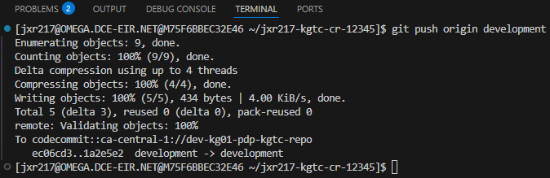

Deleting the remote repository workspace
Your remote repository workspace can be deleted, either due to deployment of your development changes or if you’d like to end development within the remote repository. To delete the repository, delete the repository folder and contents created when the branch was cloned.
Prior to deletion of your repository workspace, you should review and verify there is no uncommitted work and required committed have been pushed.
To check for uncommitted changes, use the following command:
git status
Example:
To delete the repository, use the following command:
rm -rf {remote-repo-name} /!\ WARNING!
WARNING: Any changes not pushed to the repository prior to deletion with be lost.
Example:
rm -rf jxr217-remote-kgtc-cr-12345

Deployment via Code Pipeline
Deployment of committed code.

Development Pipeline
When your code is pushed to the development branch of the CodeCommit repository, the development pipeline will launch. This is an automated process
kg01-pdp-{source-identifier}-sbic-development

Main Pipeline
When your code is pulled to the main branch of the CodeCommit repository, the main pipeline will launch. This is an automated process
kg01-pdp-{source-identifier}-sbic-main

AWS CLI
Various CLI commands as reference. Not a complete listing of all available commands.

Commands
pip install git-remote-codecommit [need to run first?] (reference: Setup steps for HTTPS connections to AWS CodeCommit with git-remote-codecommit - AWS CodeCommit)
aws codecommit list-repositories
aws codecommit list-branches --repository-name {repository-name}
git show-ref

Descriptions
The naming conventions for individual components.

Environment
Table 4: AWS Environment descriptions
Field | Description
dev | Used in the development environment for testing code in the main branch
dev1 | Used in the development environment for testing code in the development branch
test | Used in the test environment for testing code in the main branch
test1 | Used in the test environment for testing code in the main branch
prod | Production environment
sbx | sandbox

Appendix A

Glossary of Terms
This glossary contains definitions of the acronyms and abbreviations used in this document.
Table 2: Glossary
Acronym/Abbreviation | Description
ADW | Agency Data Warehouse
AWS | Amazon Web Services
BI | Business Intelligence
BPM | Business Performance Measurement
CRA | Canada Revenue Agency
eBCI | e-Business Computing Infrastructure
ETL | Extract Transform and Load
ITB | Information Technology Branch
OM&R | Operational Monitoring and Reporting
PDP | Program Data Provider
PSABA | Persistent Staging Area - Business Analytical
PSABO | Persistent Staging Area - Business Operations

Appendix B
<text for Appendix B>

Appendix B Sub-heading
<text for Appendix B Sub-heading>

Document Element Templates
This section can be removed from the document once the draft is completed.
This section contains document elements that can be copied to use elsewhere in the document to maintain consistency.

Tables
Table header row should repeat across pages.
Each table should have an associated caption, including table number and description. Caption should be placed above the table.
Table 3: Description of Table
Column 1 | Column 2 | Column 3 | Column 4 | Column 5
<value> | <value> | <value> | <value> | <value>
<value> | <value> | <value> | <value> | <value>
<value> | <value> | <value> | <value> | <value>
<value> | <value> | <value> | <value> | <value>
<value> | <value> | <value> | <value> | <value>
<value> | <value> | <value> | <value> | <value>
<value> | <value> | <value> | <value> | <value>
<value> | <value> | <value> | <value> | <value>
<value> | <value> | <value> | <value> | <value>
<value> | <value> | <value> | <value> | <value>

Figures
Each figure should have an associated caption, include figure number and description. Caption should be placed below the figure.
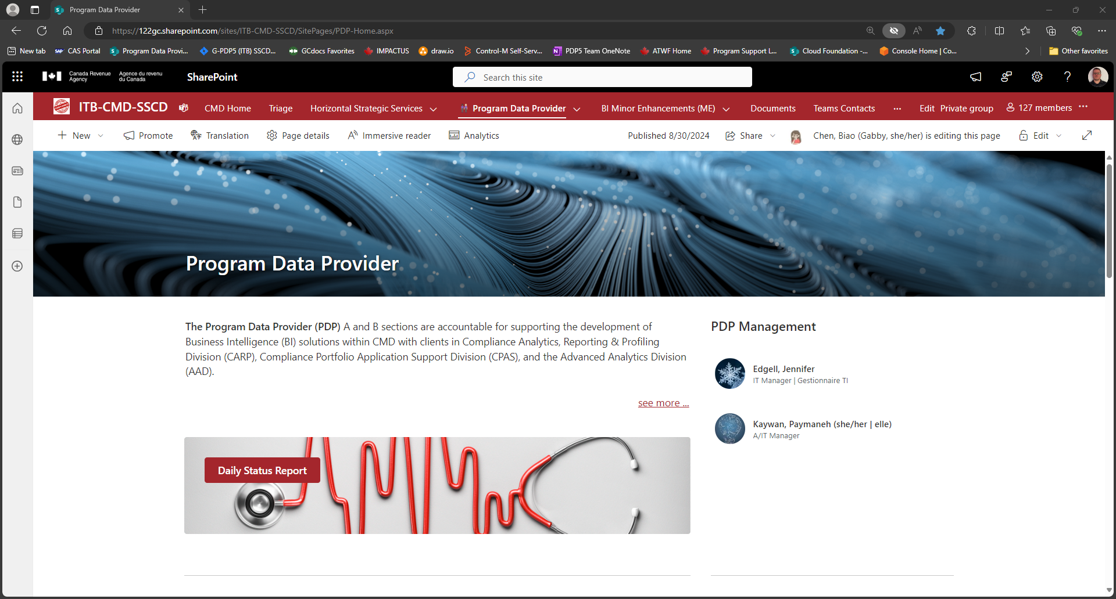
Figure 1: Description of Figure

